**CRITO VPN ADD IP ADDRESS**

* Open VPC service in left side navigation bar click on Client VPN endpoints  
  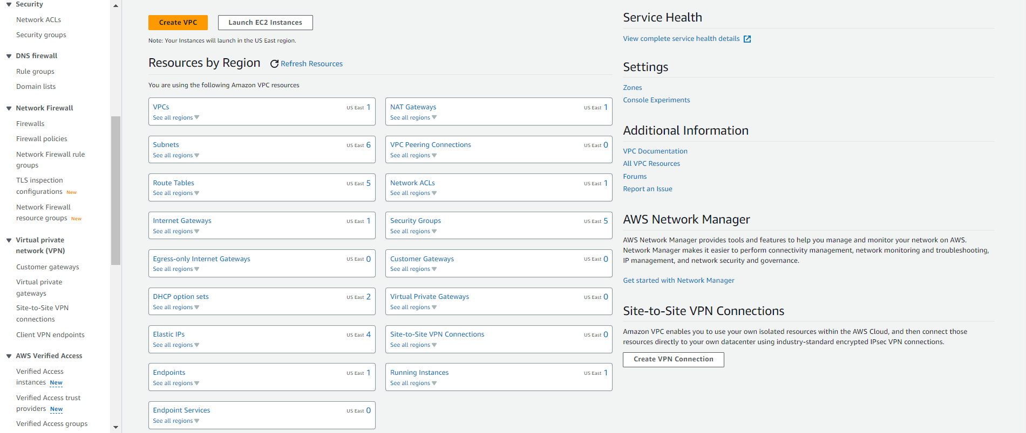
* Click on client client VPN endpoint ID [cvpn-endpoint-0510ca603068c1a17](https://us-east-1.console.aws.amazon.com/vpc/home?region=us-east-1#ClientVPNEndpointDetails:clientVpnEndpointId=cvpn-endpoint-0510ca603068c1a17)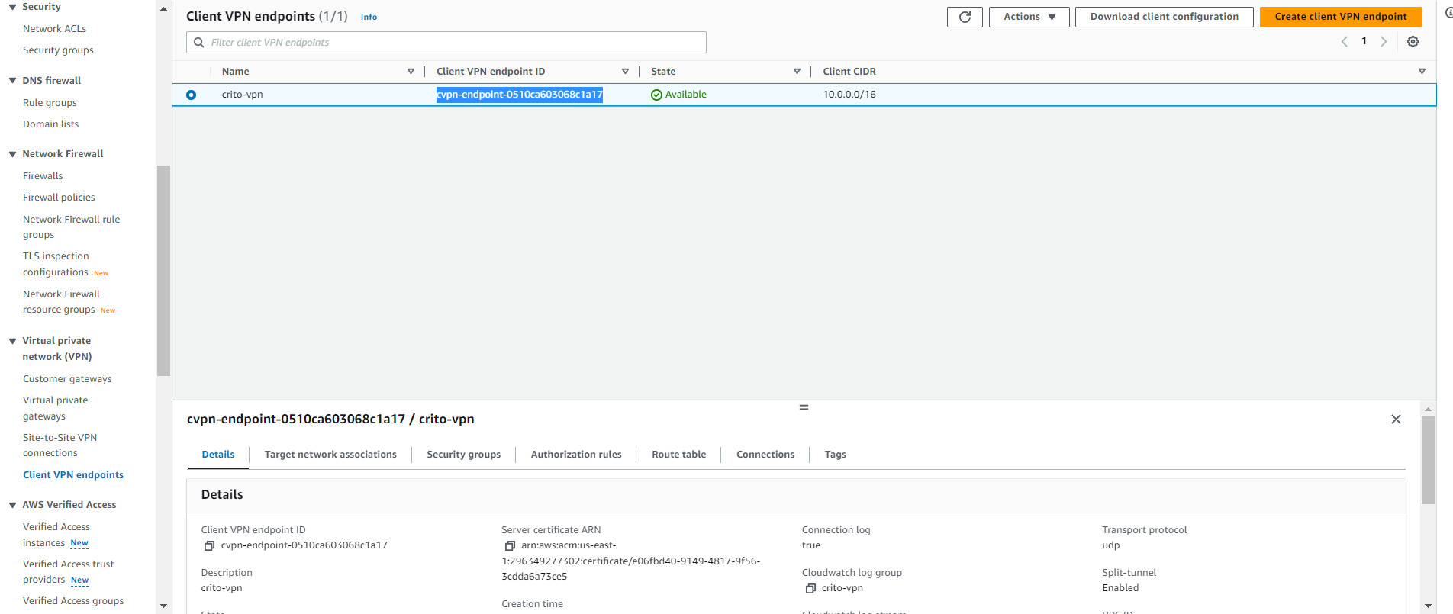
* Select authorization rule  
  Click on add authorization rule  
  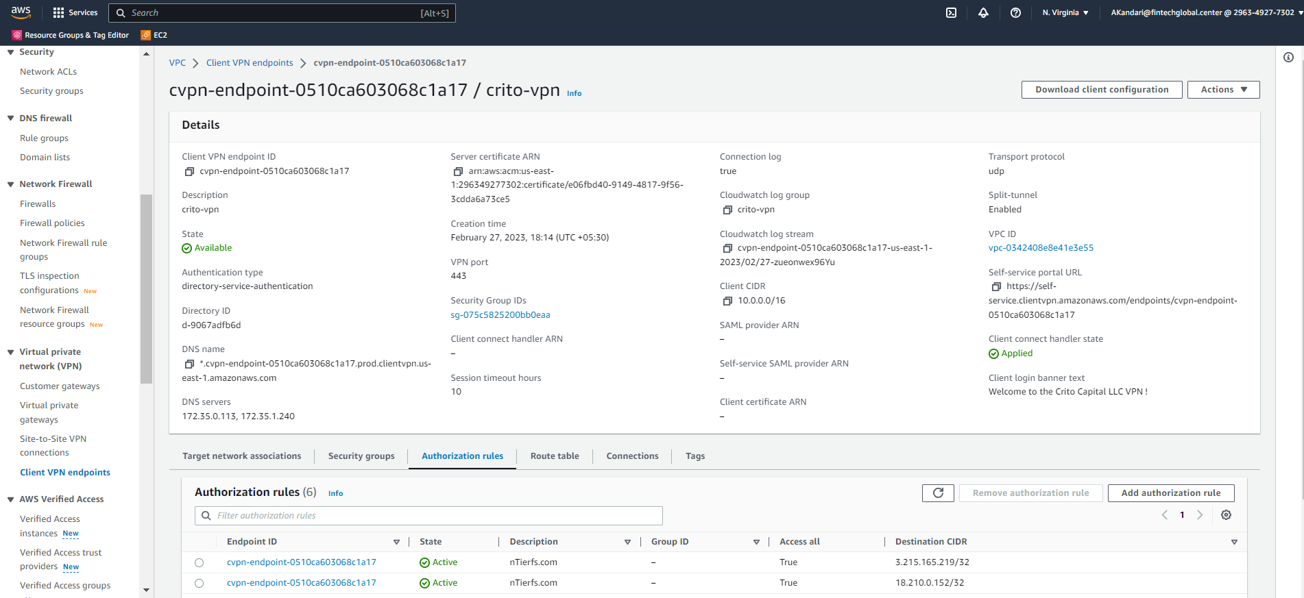
* Enter the IP address to be added in VPN  
  Enter the Descripttion for the IP address   
  Click on add authorization rule  
  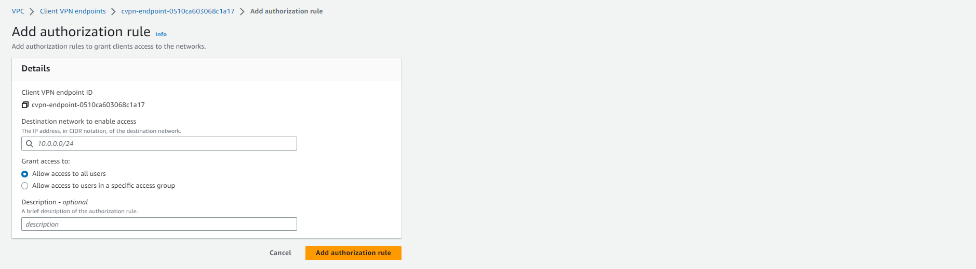
* Select Route Table in navigation bar  
  Click on Create Route  
  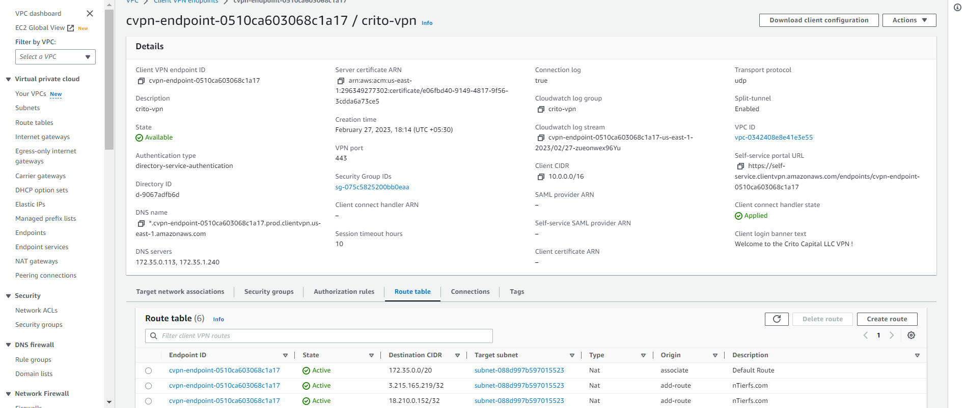
* Enter IP address to the route destination  
  Select the subnet ID   
  Add description  
  click on create Route  
  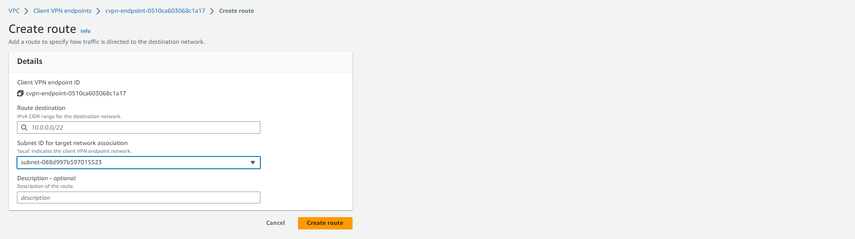
* IP address is added to the VPN